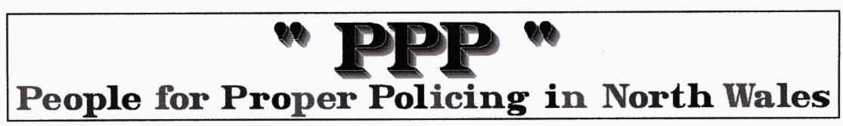

POLICE UNIFORM - Tell them what you think
This survey is currently on the NWPF website

In recent years our uniform has developed to provide operational staff with a uniform that is both practical and comfortable. We're hoping to find out what effect the uniform has on your perception of the police and will be carrying out both online and street surveys over the coming weeks.
If you have a minute or two to spare, please let us know what you think by completing the online survey below

http://www.north-wales.police.uk/nwpv2/_globalimages/uploaded/UniformSurvey/uniformSurvey.asp

The PPP comments … We have always been against Brunstrom’s base ball caps and the shift progressively towards a paramilitary style and ATTITUDE. We believe this conflicts with the Police and PA propoganda about how safe a place North Wales is. We were equally concerned about the growing emphasis and use of the TASER on animals and the elderly and the carrying of guns in crowded public places. We also believe that uniform is about ‘horses for courses’ (no we don’t WANT REAL horses)or occasions and most members of the force KNOW what we mean.

If you have an opinion now is your chance to express it … the current NWPF hierarchy will probably listen to your opinion.

